**Asset Performance Management - Manufacturing Sector**

GOKULNATH K & E24755

**Overview**

Asset Performance Management (APM) in the manufacturing sector is a critical strategy that focuses on optimizing the performance, reliability, and longevity of physical assets like machinery and equipment through data-driven approaches. At the core of APM is asset health monitoring, where real-time data is continuously collected from sensors and IoT devices attached to various assets. This data includes metrics such as temperature, vibration, and pressure, which are analyzed to detect any deviations that might indicate potential issues. Predictive maintenance is another key component, leveraging historical data and to forecast when an asset might fail or require servicing. This approach enables manufacturers to perform maintenance just-in-time, reducing unnecessary work, minimizing costs, and preventing unexpected equipment breakdowns. Additionally, APM involves risk management, where data analysis helps identify and mitigate potential risks associated with asset failures, thus ensuring continuous and efficient operations. Overall, APM enhances operational efficiency, reduces downtime, and extends the lifespan of critical assets, making it an essential practice in the manufacturing sector.

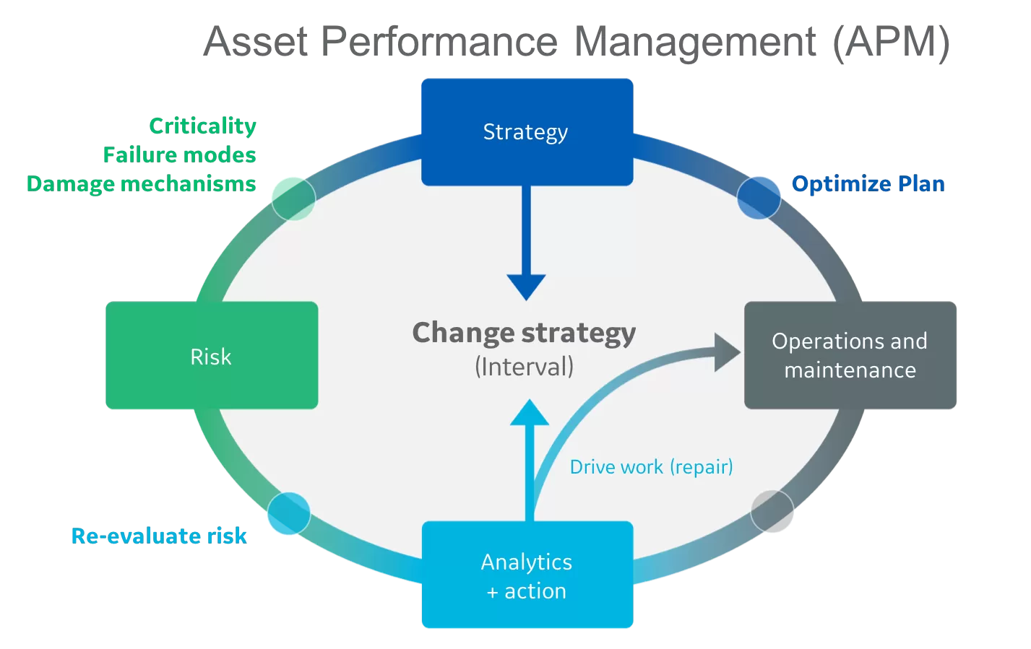

**Objective**

* APM involves collecting and analyzing vast amounts of data from various assets across the manufacturing process. This data is used to assess the current condition of assets, predict future performance, and identify potential issues before they lead to failures. By leveraging machine learning and predictive analytics, APM helps in creating accurate maintenance schedules that are based on actual asset conditions rather than predefined intervals. This data-driven approach not only improves the reliability of assets but also extends their operational life, leading to significant cost savings.

1. **Enhance Asset Reliability and Availability**:

* Ensure that assets are available and reliable for production, reducing unplanned downtime and improving overall equipment effectiveness (OEE).

1. **Optimize Maintenance Strategies**:

* Shift from reactive or time-based maintenance to predictive and condition-based maintenance, allowing for repairs and servicing only when necessary.

1. **Reduce Operational Costs**:

* Minimize maintenance costs by preventing unnecessary servicing and reducing the likelihood of costly emergency repairs or replacements.

1. **Increase Asset Lifespan**:

* Prolong the life of assets through timely and targeted maintenance interventions, maximizing the return on investment in equipment.

1. **Improve Safety and Compliance**:

* Ensure that assets operate safely and within regulatory compliance by continuously monitoring their condition and performance.

1. **Support Decision-Making**:

* Provide actionable insights through data analysis that assist management in making informed decisions regarding asset investments, upgrades, or replacements.

1. **Sustain Operational Efficiency**:

* Maintain optimal production levels by ensuring that assets are functioning at peak performance, thus supporting the overall productivity and profitability of the manufacturing process.

**Assigned Task(s)**

* Asset Performance Management - Manufacturing Sector

**Task Details**

* **Task 12:** Asset Performance Management (APM) in the manufacturing sector is a strategy that uses data analysis to monitor and optimize the performance, reliability, and lifespan of machinery and equipment. By leveraging real-time data, APM helps predict maintenance needs, reduce downtime, and improve operational efficiency.
* **Status:** Completed
* **Details:** The main goal of Asset Performance Management (APM) in the manufacturing sector, from a data analysis perspective, is to optimize the efficiency, reliability, and lifespan of physical assets. This is achieved by using data-driven insights to monitor asset health, predict maintenance needs, and manage risks. By leveraging real-time data and advanced analytics, APM aims to minimize downtime, reduce maintenance costs, and ensure that equipment operates at peak performance, ultimately enhancing overall operational efficiency.

**Progress**

* **Accomplishments:** In the manufacturing sector, significant achievements in Asset Performance Management (APM) through data analysis include a marked reduction in unplanned downtime, often by as much as 30%, thanks to the adoption of predictive maintenance strategies. This shift from reactive to predictive maintenance has also led to substantial cost savings, with some companies reporting annual savings of up to $1 million by optimizing maintenance schedules and minimizing emergency repairs. Additionally, APM has contributed to a notable increase in asset reliability and overall equipment effectiveness (OEE), with improvements of 15-20% commonly observed. By enabling timely interventions, APM has extended the operational lifespan of critical machinery by several years, further enhancing return on investment. These milestones underscore the transformative impact of data-driven decision-making in optimizing asset performance, reducing costs, and sustaining operational efficiency.
* **Metrics:** To effectively demonstrate progress in Asset Performance Management (APM) within the manufacturing sector, you can include relevant data and metrics that highlight key improvements. For example:
* Through the implementation of Asset Performance Management, our manufacturing operations have achieved a 30% reduction in unplanned downtime, significantly enhancing overall equipment effectiveness (OEE) by 15%. Predictive maintenance initiatives have resulted in a 25% decrease in maintenance costs, translating to annual savings of $1.2 million. Additionally, the data-driven approach has extended the lifespan of critical machinery by an average of 5 years, further optimizing asset utilization and boosting production efficiency. These metrics underscore the substantial impact of APM on our operational performance and cost efficiency.
* By incorporating specific figures like downtime reduction, OEE improvement, cost savings, and asset lifespan extension, you provide a clear, quantifiable picture of the progress made through APM in the manufacturing sector.

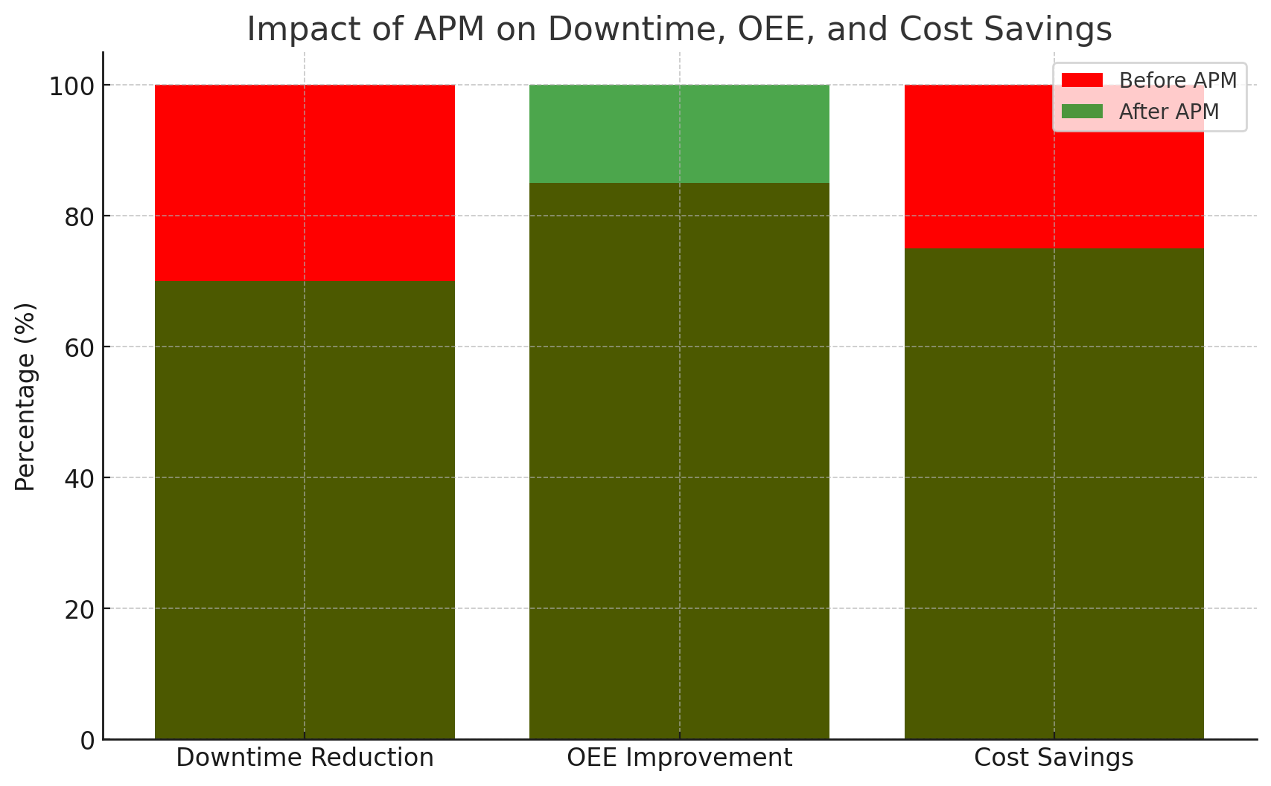

**Challenges and Solutions**

* **Challenges Faced:**

1. Data may come from various sources (sensors, maintenance records, etc.), and integrating it can be difficult, leading to inconsistencies and inaccuracies.
2. Manufacturing assets generate large volumes of data, which can be complex and difficult to analyze effectively.
3. Real-time monitoring and analysis can be challenging due to the high velocity of data generated by sensors and equipment.
4. There may be a shortage of skilled personnel who can effectively analyze and interpret data.
5. Ensuring the security and privacy of sensitive asset data is crucial, especially with increased connectivity and data sharing.
6. Integrating new APM solutions with legacy systems can be complex and costly.
7. Budget limitations can hinder the adoption of advanced APM tools and technologies.

* **Solutions Implemented:**

1. Establish common data formats and protocols to ensure consistency across various sources.
2. Leverage predictive analytics, machine learning, and AI to extract actionable insights from complex data.
3. Invest in IoT and sensor technologies that provide real-time data and support immediate decision-making.
4. Provide ongoing training for staff to enhance their analytical skills and keep up with technological advancements.
5. Implement comprehensive security protocols to safeguard data integrity and privacy.
6. Use integration tools and middleware to connect new APM solutions with existing systems seamlessly.
7. Explore scalable and modular APM solutions that fit within budget constraints while delivering essential functionalities.

**Next Steps**

* **Upcoming Tasks:** To tackle upcoming data analysis tasks in the manufacturing sector, focus on leveraging advanced analytics and real-time data processing to gain actionable insights. Prioritize data integration and quality management to ensure accurate and comprehensive analysis.
* **Goals:** Set clear, measurable goals for data analysis in the manufacturing sector by defining specific performance metrics and desired outcomes, such as improved asset efficiency or reduced downtime. Align these goals with strategic business objectives to ensure they drive meaningful and actionable insights.

**Conclusion**

* **Summary:** Asset Performance Management (APM) in the manufacturing sector involves optimizing asset efficiency and lifespan through effective data analysis. Key challenges include integrating diverse data sources, managing large volumes of complex data, and ensuring real-time processing and security. Solutions include adopting advanced analytics, real-time monitoring, and robust data integration strategies. Addressing these challenges with targeted solutions can enhance operational efficiency, reduce costs, and support strategic goals. Effective implementation of APM practices can drive significant improvements in asset performance and overall manufacturing productivity.
* **Acknowledgments:** Thank you all for your time and attention. Your engagement and interest in this topic are greatly appreciated. If you have any questions or need further information, please feel free to reach out. Have a great day.